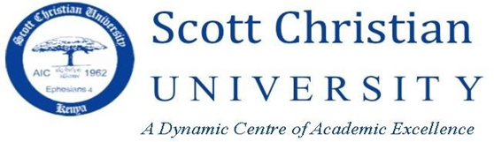

SCHOOL OF EDUCATION AND BUSINESS STUDIES
BACHELOR OF EDUCATION ARTS/DIPLOMA IN EDUCATION
COURSE CODE/NAME: EDU 111/EFN0101: HISTORY OF EDUCATION
MAY–AUGUST, 2026.END OF SEMESTER EXAMINATION
LECTURER: DR. ROSE MALLEI TIME 2 HOURS
Instructions: Answer Question ONE (COMPULSORY) and any other TWO questions in SECTION
SECTION A
QUESTION ONE (30 MARKS)
Describe five features of ancient Greek education and explain how these have been adapted in modern civilization (10 marks)
Discuss five features of African indigenous education with special reference to a specific community in Kenya (10 marks)
Discuss three educational ideas of each of the following Educationists and explain how they have been incorporated into Kenya’s education system:
Friendrich Froebel (5 marks)
Quintilian (5 marks)
QUESTION TWO (15 MARKS)
Using relevant examples, explain four challenges education in Africa is facing and suggest strategies adopted to address them since independence (8 marks)
Examine the influence of Ancient Greece and Egypt on modern educational theory and practice (7 marks)
QUESTION THREE (15 MARKS)
Explain four tendencies in European education that developed in the Renaissance period (8marks)
Identify three contributions to education made by Martin Luther (1483 – 1546) (7 marks)

QUESTION FOUR (15 MARKS)
Using relevant examples, explain the influence of the teaching methods and content used in Egypt on education in Kenya (8 marks)
Assess the influence of religion on the theory and practice of education in Kenya to day (7 marks)
QUESTION FIVE (15 MARKS)
With relevant examples, discuss Four challenges that head teachers are facing in the provision of Junior School education in Kenya (8 marks)
Suggest Three solutions to the challenges discussed (7 marks)

