
SCHOOL OF EDUCATION AND BUSINESS STUDIES
BACHELOR OF INFORMATION COMMUNICATION TECHNOLOGY/ BACHELOR OF BUSINESS INFORMATION TECHNOLOGY
UNIT CODE/NAME: BCT 212/BBIT 414: DATA STRUCTURES AND ALGORITHMS
May - August 2025/2026 End Semester Exam - Time: 2 Hours
Instructions: Answer Question ONE (Compulsory) and any other TWO Questions.
QUESTION ONE: Compulsory (30 Marks)
- Define the following terms:
- Algorithm (1 Mark)
- Data structure (1 Mark)
- Spanning tree (1 Mark)
- Assume that you’re a software developer for a given company and you have been requested to develop a C program that does the following:
- Accepts inputs of the ages of 10 employees of the company. The values of the ages are of integer data type.
- Stores the values of the ages in an array named emplAges.
- Outputs the values of the ages of the second and seventh employees.
Write the above program segment. (4 Marks)
- Summarize three reasons on why we concentrate on worst-case running time during algorithm analysis. (3 Marks)
- Describe how a queue differs from a stack in their operation (3 Marks)
- Using Prim’s algorithm, derive the minimum spanning tree and calculate its cost for the below undirected graph. (5 Marks)
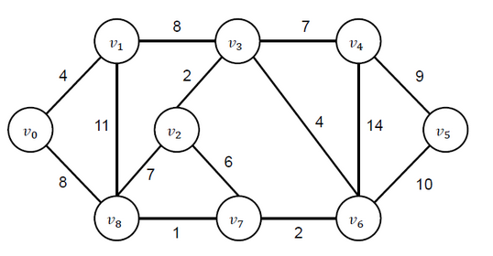
- A linked list is a crucial data structure in software development. Explain any five operations that may be applied and their use. (5 Marks)
- EduLearn is transitioning its old, monolithic Learning Management System into a modern architecture. The engineering team is divided: one faction wants a Function-Oriented design utilizing modular procedures, while another pushes for an Object-Oriented paradigm to mirror real-world campus entities.
- Explain how data and functions interact within the Function-Oriented Design paradigm.
(2 Marks)
- Evaluate the Object-Oriented Design (OOD) approach. Explain how the concepts of Encapsulation and Inheritance would apply to EduLearn entities like User, Student, and Instructor. (3 Marks)
- Recommend which of the two methodologies is better suited for a highly scalable system that requires frequent feature updates and interactive components. Justify your choice. (2 Marks)
QUESTION TWO (15 Marks)
- Consider the array below:
int marks1[5] = {56,78,86,54,60};
Write a C++ code fragment that copies the values in the array to a new array named marks2. (3 Marks)
- Stacks are special kinds of lists with unique operation. Explain any three stack operations.
(3 Marks)
- AeroNav is preparing a mission-critical update for its commercial drone autopilot unit. Because a software failure could result in physical hardware destruction or safety hazards, the testing cycle must be watertight, thoroughly documented, and maintainable for future aviation audits.
- Differentiate clearly between Software Verification and Software Validation within the context of the AeroNav firmware update. (2 Marks)
- Describe how the QA team would employ Black-Box Testing versus White-Box Testing to verify the autopilot's emergency landing sub-routine. (2 Marks)
- Explain why Software Documentation is critical during the Software Maintenance phase of a system's lifecycle, especially when a new engineering team inherits the codebase years later. (2 Marks)
- Discuss three reasons why AeroNav may require software maintenance. (3 Marks)
QUESTION THREE (15 Marks)
- Rewrite the following program after removing the syntactical errors (if any). Underline each correction. (4 Marks)
struct Pixels
{
int color, style;
}
void showPoint(Pixels P)
{
cout << P.color, P.style << endl;
}
int main()
{
Pixels Point1 = (5, 3);
showPoint(Point1);
Pixels Point2 = Point1;
color.Point1 += 2;
showPoint(Point2);

return 0;
}
- To scale up operations, a micro-lending app moves to a high-volume processing layer. It requires sorting algorithms that leverage divide-and-conquer principles or faster structural partitions to manage large batches of integers with predictable execution time limits.
- Walk through the partitioning phase of Quick Sort using the array [40, 20, 70, 10, 50]. Use 50 as your pivot element and show the resulting left and right sub-arrays. (4 Marks)
- Illustrate how Merge Sort processes the array [18, 4, 22, 40, 21, 5, 12]. Draw the split phases (divide) and the combined phases (conquer) showing how sorted sub-arrays are joined. (4 Marks)
- Consider the following list: 6, 17, 8, 20, 12, 14, 10 and 9. Showing clearly the list in each iteration, sort the list in descending using Bubble sort. (3 Marks)
QUESTION FOUR (15 Marks)
- Describe any three types of software testing. (3 Marks)
- Describe any three types of documentation which can be used in software development.
(3 Marks)
- Consider the undirected graph below, and find the shortest path between nodes f and b using:
- Dijkstra’s algorithm (4 Marks)
- Floyd’s algorithm (5 Marks)
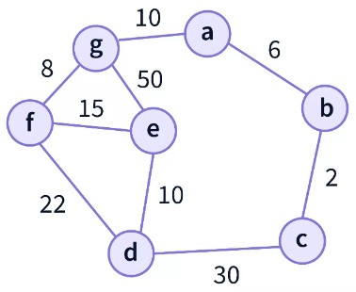
QUESTION FIVE (15 Marks)
- An online micro-lending app processes thousands of small financial transaction balances hourly. Before applying advanced sorting optimizations, the engineering team needs to benchmark simple, intuitive, "in-place" sorting algorithms on small, randomized blocks of user balances to understand foundational algorithmic overhead.
- Provide a step-by-step trace of an Insertion Sort applied to the following list of account balances in descending order: [25, 12, 45, 7, 19, 54]. Show the list configuration after each outer loop pass. (3 Marks)
- Considering the same, showing clearly the list in each iteration, sort the list in ascending order using selection sort (3 Marks)
- Trees are ideally suited to representing hierarchical relationships among elements in a universe. Consider the tree show below.
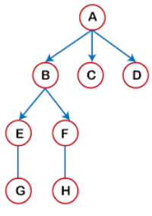
- Determine the preorder, inorder and postorder of the tree traversals. (6 Marks)
- Provide the order in which a Breadth First Search shall be executed. (3 Marks)

