
SCHOOL OF EDUCATION AND BUSINESS STUDIES
BACHELOR OF INFORMATION COMMUNICATION TECHNOLOGY
UNIT CODE/NAME: BCT 212: DATA STRUCTURES AND ALGORITHMS
January - April 2025/2026 End Semester Exam - Time: 2 Hours
Instructions: Answer Question ONE (Compulsory) and any other TWO Questions.
QUESTION ONE: Compulsory (30 Marks)
- Define the following terms:
- Algorithm (1 Mark)
- Data structure (1 Mark)
- Spanning tree (1 Mark)
- Queue (1 Mark)
- Assume that you’re a software developer for a given company and you have been requested to develop a C++ program that does the following:
- Accepts inputs of the ages of 10 employees of the company. The values of the ages are of integer data type.
- Stores the values of the ages in an array named emplAges.
- Outputs the values of the ages of the second and seventh employees.
Write the above program segment. (6 Marks)
- Summarize three reasons on why we concentrate on worst-case running time during algorithm analysis. (3 Marks)
- Describe how a queue differs from a stack in their operation (3 Marks)
- Using Prim’s algorithm, derive the minimum spanning tree and calculate its cost for the below undirected graph. (5 Marks)
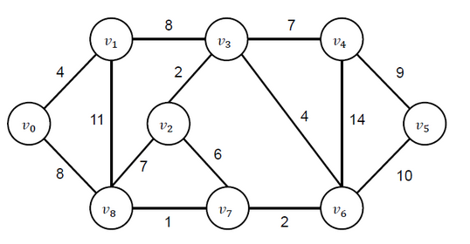
- A linked list is a crucial data structure in software development. Explain any five operations that may be applied and their use. (5 Marks)
- Describe the following strategies for handling data structures and algorithms:
- Greedy approach (2 Marks)
- Divide and conquer (2 Marks)
QUESTION TWO (15 Marks)
- Briefly explain how the below program segment executes until it terminates.
for( i=1; i<=30; i++)
{
cout << i;
} (3 Marks)
- Consider the array below:
int marks1[5] = {56,78,86,54,60};
Write a C++ code fragment that copies the values in the array to a new array named marks2. (3 Marks)
- Stacks are special kinds of lists with unique operation. Explain any three stack operations.
(3 Marks)
- Differentiate between software validation and software verification. (2 Marks)
- Discuss three reasons why we require software maintenance. (3 Marks)
QUESTION THREE (15 Marks)
- Rewrite the following program after removing the syntactical errors (if any). Underline each correction. (4 Marks)
struct Pixels
{
int color, style;
}
void showPoint(Pixels P)
{
cout << P.color, P.style << endl;
}
int main()
{
Pixels Point1 = (5, 3);
showPoint(Point1);
Pixels Point2 = Point1;
color.Point1 += 2;
showPoint(Point2);

return 0;
}
- Using brief statements, describe how you can insert another node between the nodes a, and b in the linked list below. (5 Marks)
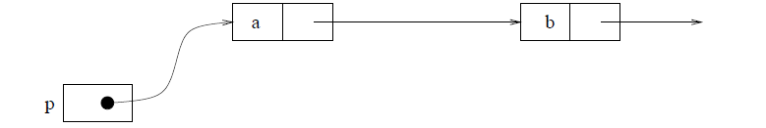
- Consider the following list: 6, 17, 8, 20, 12, 14, 10 and 9. Showing clearly the list in each iteration, sort the list in descending using:
- Bubble sort (3 Marks)
- Merge sort (3 Marks)
QUESTION FOUR (15 Marks)
- Describe any three types of software testing. (3 Marks)
- Describe any three types of documentation which can be used in software development.
(3 Marks)
- Consider the undirected graph below, and find the shortest path between nodes f and b using:
- Dijkstra’s algorithm (4 Marks)
- Floyd’s algorithm (5 Marks)
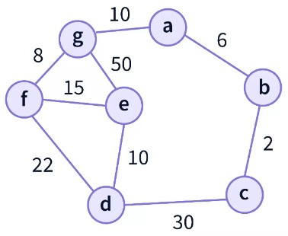
QUESTION FIVE (15 Marks)
- Consider the following list: 38, 27, 43, 25, 3, 9, 82, and 10. Showing clearly the list in each iteration, sort the list in ascending order using:
- Selection sort (3 Marks)
- Insertion sort (3 Marks)
- Trees are ideally suited to representing hierarchical relationships among elements in a universe. Consider the tree show below.
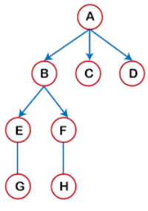
- Determine the preorder, inorder and postorder of the tree traversals. (6 Marks)
- Provide the order in which a Breadth First Search shall be executed. (3 Marks)

